CentOS installation Procedure for SC4S

What is Splunk connect for Syslog?

Splunk Connect for Syslog is an open source packaged solution for getting data into Splunk. It is based on the syslog-ng Open Source Edition (Syslog-NG OSE) and transports data to Splunk via the Splunk HTTP event Collector (HEC) rather than writing events to disk for collection by a Universal Forwarder.

Prequisition for CentOS.

1. ISO image in Nutanix Image configuration
2. Hostname
3. IP Address

Server Information

* SJC8-SC4S
  + Sjc8-sc4s-01
  + IP Address: 100.123.3.17
  + Subnet Mask: 255.255.255.240
  + Gateway: 100.123.3.1
  + DNS: 100.123.12.20, 100.123.12.21
* SIN99-SC4S
  + Sin99-sc4s-01
  + IP Address: 100.125.163.110
  + Subnet Mask: 255.255.255.240
  + Gateway: 100.123.163.97
  + DNS: 100.125.164.10,100.125.164.11

Resource Information

* + CPU : 1 Core / 2 Vcpus’s
  + Memory : 16 GB
  + Disk(ISCI) : 100 GB

Installation Procedure

boot from your bootable drive, and you will meet with the following screen. Choose the first option which will start the installer.

[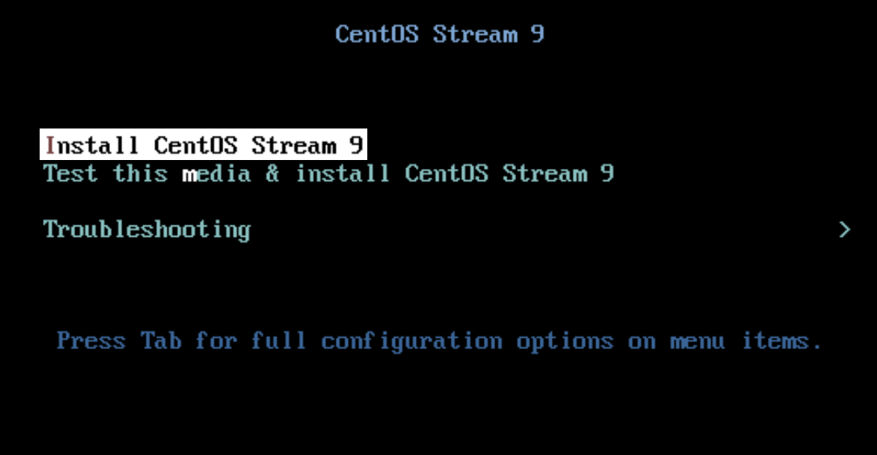](https://www.tecmint.com/wp-content/uploads/2022/05/CentOS-Stream-Boot-Menu.png)CentOS Stream Boot Menu

**Step 2: Choose Installer Language**

**CentOS Stream** uses the **Anaconda** installer which is one of the rare installers which has a separate prompt just for selecting installer language. You can choose what comforts you the most but for the majority, **English** will be the correct option and we are going with that.

CentOS Stream Language

**Step 3: Setting Up Localization**

In this step, we are going to configure all the available options under the **Localization** section which are **Keyboard**, **Language Support**, and **Time & Date**. Let’s Start with **Keyboard**.

Select **Keyboard** Option

[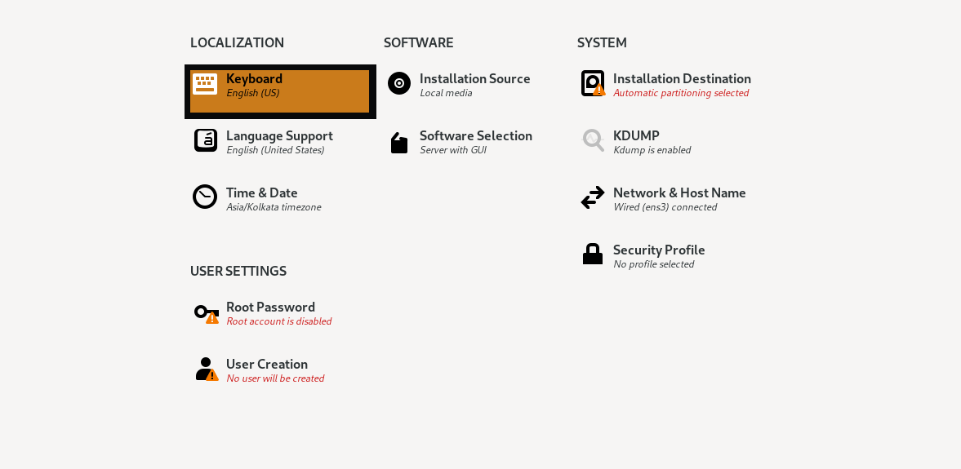](https://www.tecmint.com/wp-content/uploads/2022/05/CentOS-Stream-Keyboard.png)CentOS Stream Keyboard

Now Click on **Language Support** where we can choose additional languages required by the user to work.

[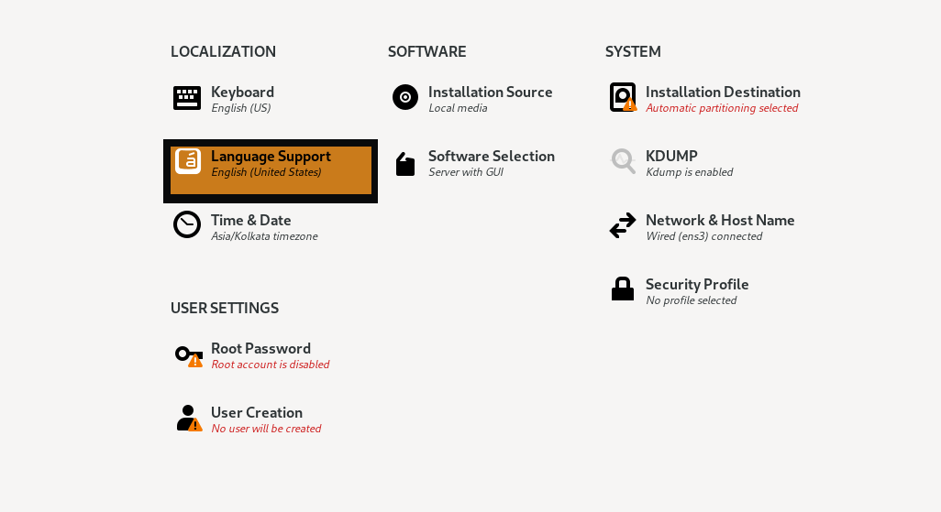](https://www.tecmint.com/wp-content/uploads/2022/05/CentOS-Stream-Language-Support.png)CentOS Stream Language Support

From here you can choose the additional language you want to get supported on your system. I only use **English** so I’m going with default options.

Select the last option in **Localization** labelled “**Time & Date**” to choose our region.

[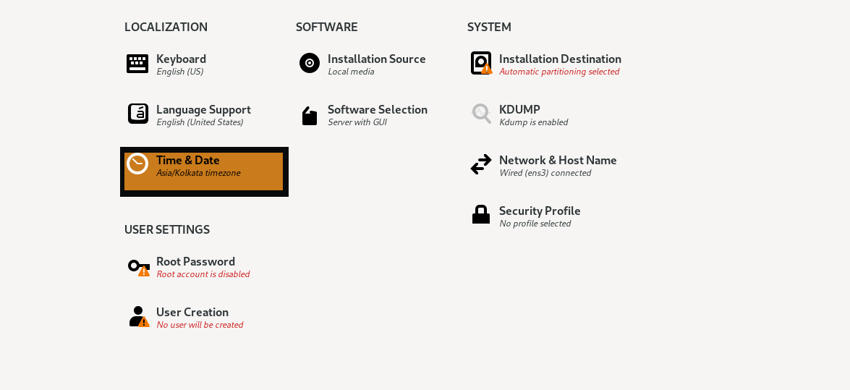](https://www.tecmint.com/wp-content/uploads/2022/05/CentOS-Stream-Time-Date.png)CentOS Stream Time and Date

**Step 4: Installation Destination**

In this step , we will select Disk with automatic partition

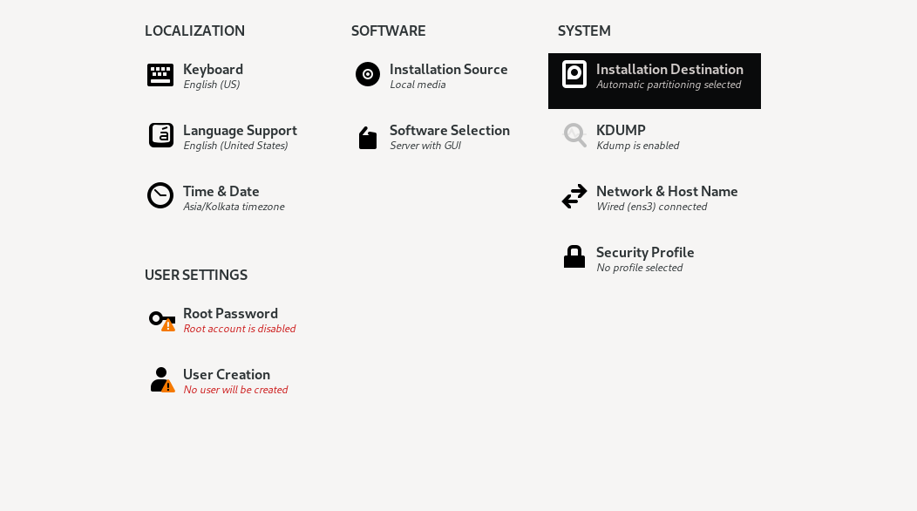

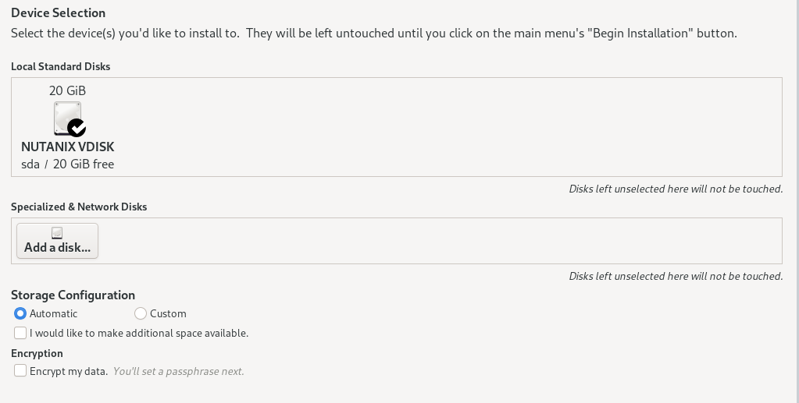

**Step 5: Setting Up Software Options**

In this step, we are going to choose the software required for our system. We will not make any changes to the installation source as it will automatically detect the local media. So let’s start with the **Software** selection.

Click on the 2nd option labelled as “**Software Selection**”.

[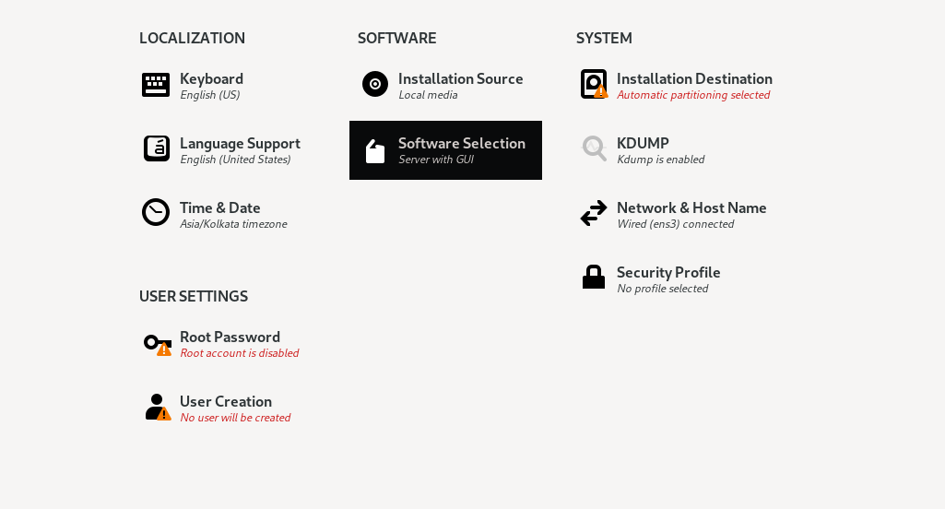](https://www.tecmint.com/wp-content/uploads/2022/05/CentOS-Stream-Software.png)

From here you can select the important tools you require. I’m going with the minimal installation which will also exclude GUI and have an option for custom OS.

#### Step 6: Setting Network and Hostname

In this step, we are going to allocate the hostname to our system including setting up networking. Click on “**Network & Hostname**”.

[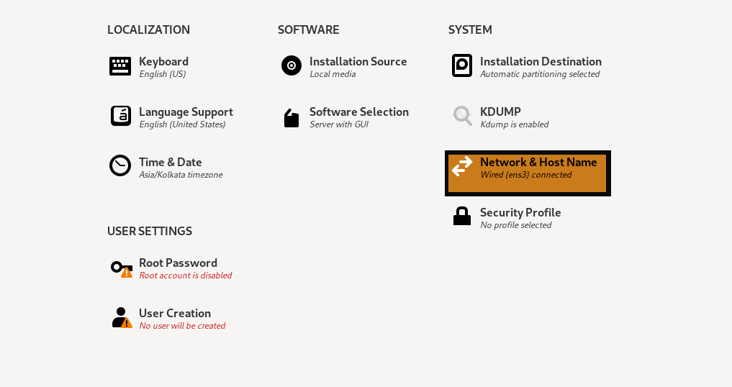](https://www.tecmint.com/wp-content/uploads/2022/05/CentOS-Stream-Network.png)CentOS Stream Network

If you are using **Ethernet**, you just have to enable it by the given button. To allocate the **hostname**, you are given a separate section. In my case, I’m going to use **tecmint**.

CentOS Stream Network Configure

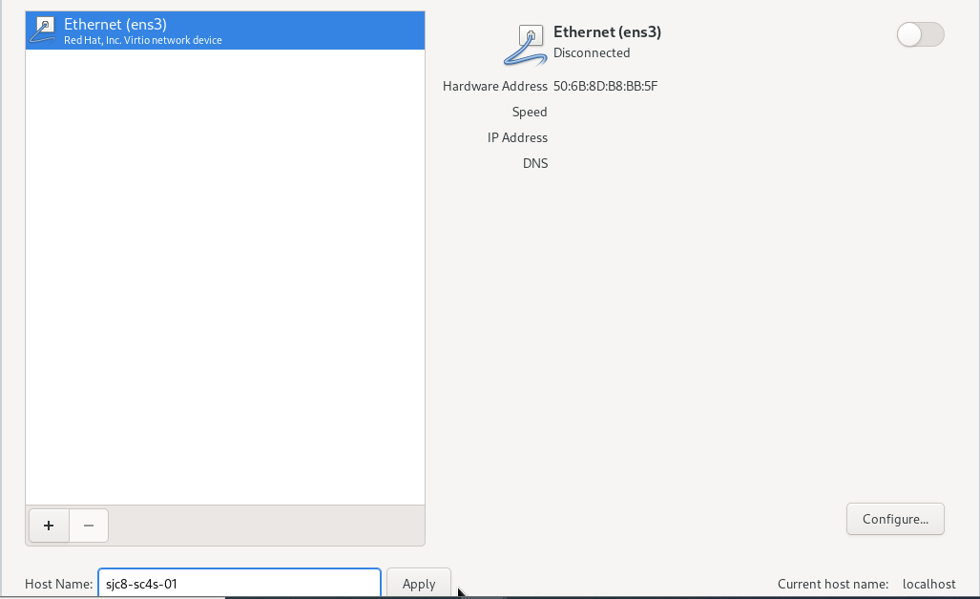

In case you are not using **DHCP**, click on **Configure** which will direct us to set up our network manually. From here, click on **Ipv4** and choose the **Manual** method. Add your desired **Address**, **Netmask** and **Gateway** by clicking on **Add** button. In the end, add **DNS** and save the configuration.

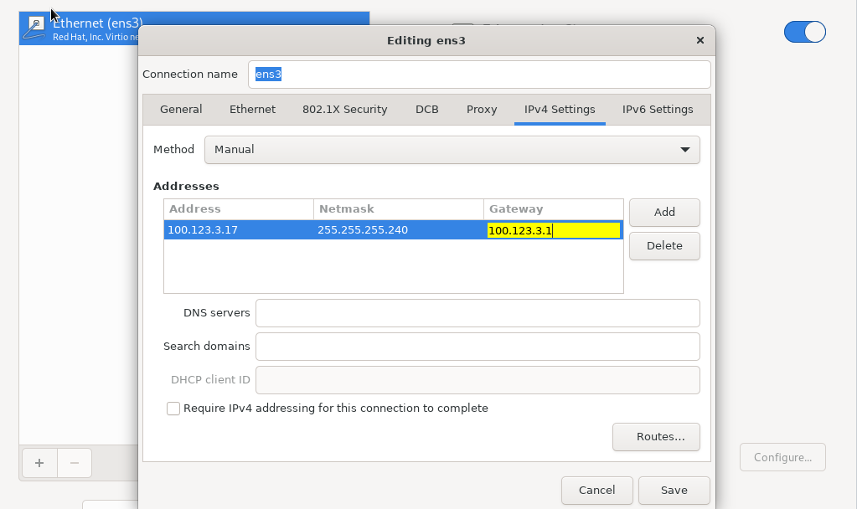

#### Step 7: Create a User Account

To create a user, click on the **User** creation option which will direct you to a prompt where you are going to add users and create a password.

[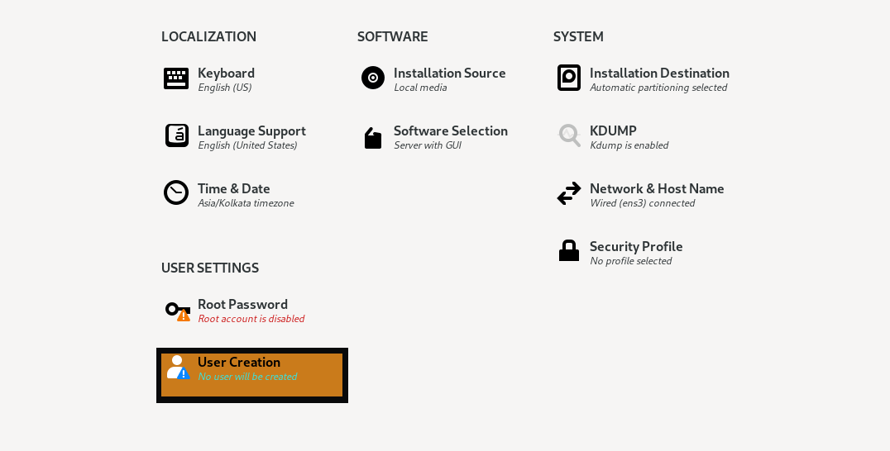](https://www.tecmint.com/wp-content/uploads/2022/05/CentOS-Stream-User.png)CentOS Stream User Account

Change the root password and create user account Enter details such as Full name, password, etc. If you want, you can make this user administrator by giving the option. We always recommend you use a strong password

Root password change and enable SSH.

Creation of new user

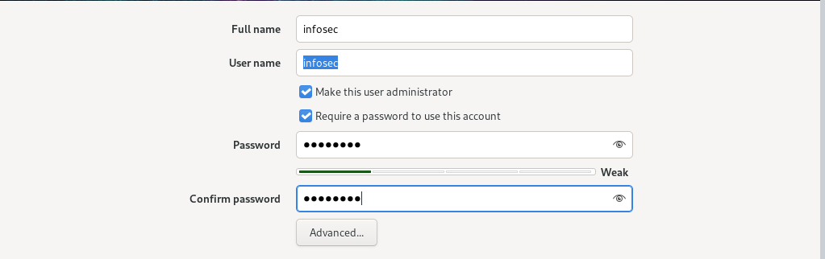

Click on **Begin** installation button and it will start the installation process. Once the installation is complete, click on **Reboot** System.

Begin CentOS Stream 9 Installation

[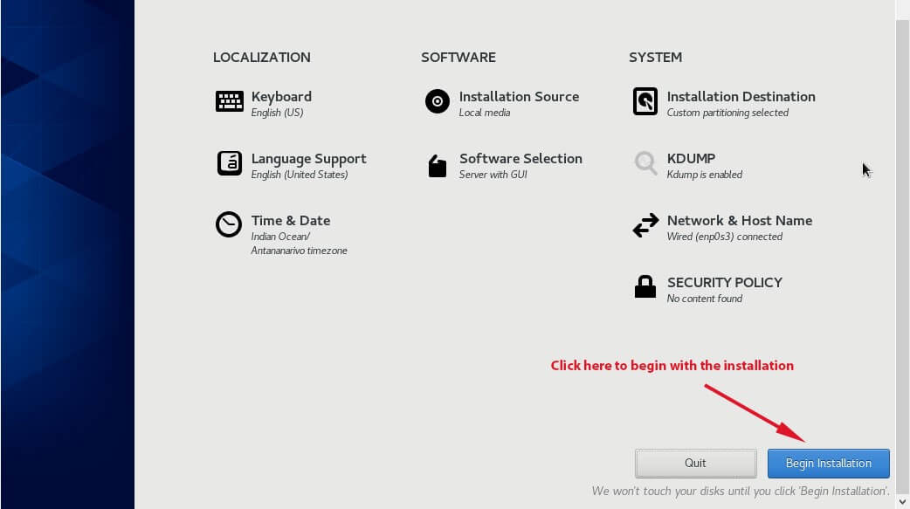](https://www.tecmint.com/wp-content/uploads/2022/05/Begin-CentOS-Stream-9-Installation.jpg)

#### Step 8: Enable GNOME at Boot

Once you reboot your system, you will be prompted with CLI. log in with your username and password.

CentOS Stream Login

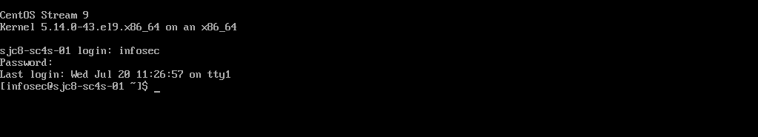

Assign Static IP Address

**if you did not set HostName, set it like follows**

**[root@localhost ~]#**

[**hostnamectl**](https://www.server-world.info/en/command/html/hostnamectl.html)**set-hostname <hostname>**

**# display devices**

**[root@localhost ~]#**

**nmcli device**

**DEVICE TYPE STATE CONNECTION**

**Ens3 ethernet connected ens3**

**lo loopback unmanaged --**

**# set IPv4 address**

**[root@localhost ~]#**

**nmcli connection modify ens3 ipv4.addresses 100.120.3.130/28**

**# set gateway**

**[root@localhost ~]#**

**nmcli connection modify ens3 ipv4.gateway 100.120.3.1**

**# set DNS**

**# for multiple DNS, specify with space separated ⇒ ipv4.dns "10.0.0.10 10.0.0.11 10.0.0.12"**

**[root@localhost ~]#**

**nmcli connection modify ens3 ipv4.dns “100.120.12.20 100.120.12.21”**

**# set DNS search base (your domain name -for multiple one, specify with space separated)**

**[root@localhost ~]#**

**nmcli connection modify ens3 ipv4.dns-search srv.world**

**# set [manual] for static setting (it's [auto] for DHCP)**

**[root@localhost ~]#**

**nmcli connection modify ens3 ipv4.method manual**

**# restart the interface to reload settings**

**[root@localhost ~]#**

**nmcli connection down enp1s0; nmcli connection up enp1s0**

**Connection 'enp1s0' successfully deactivated (D-Bus active path: /org/freedesktop/NetworkManager/ActiveConnection/1)**

**Connection successfully activated (D-Bus active path: /org/freedesktop/NetworkManager/ActiveConnection/2)**

**# confirm settings**

**[root@localhost ~]#**

**nmcli device show enp1s0**

**GENERAL.DEVICE: enp1s0**

**GENERAL.TYPE: ethernet**

**GENERAL.HWADDR: 52:54:00:DF:87:AD**

**GENERAL.MTU: 1500**

**GENERAL.STATE: 100 (connected)**

**GENERAL.CONNECTION: enp1s0**

**GENERAL.CON-PATH: /org/freedesktop/NetworkManager/ActiveC>**

**WIRED-PROPERTIES.CARRIER: on**

**IP4.ADDRESS[1]: 10.0.0.30/24**

**IP4.GATEWAY: 10.0.0.1**

**IP4.ROUTE[1]: dst = 10.0.0.0/24, nh = 0.0.0.0, mt = 1>**

**IP4.ROUTE[2]: dst = 0.0.0.0/0, nh = 10.0.0.1, mt = 100**

**IP4.DNS[1]: 10.0.0.10**

**IP4.SEARCHES[1]: srv.world**

**IP6.ADDRESS[1]: fe80::5054:ff:fedf:87ad/64**

**IP6.GATEWAY: --**

**IP6.ROUTE[1]: dst = fe80::/64, nh = ::, mt = 100**